# Assignment 6 Use Case

1. Spending Activity Management Application
   1. This app will save the history of money activities like spending and adding in a database and filter the database based on start/end dates and/or min and max amounts
      1. 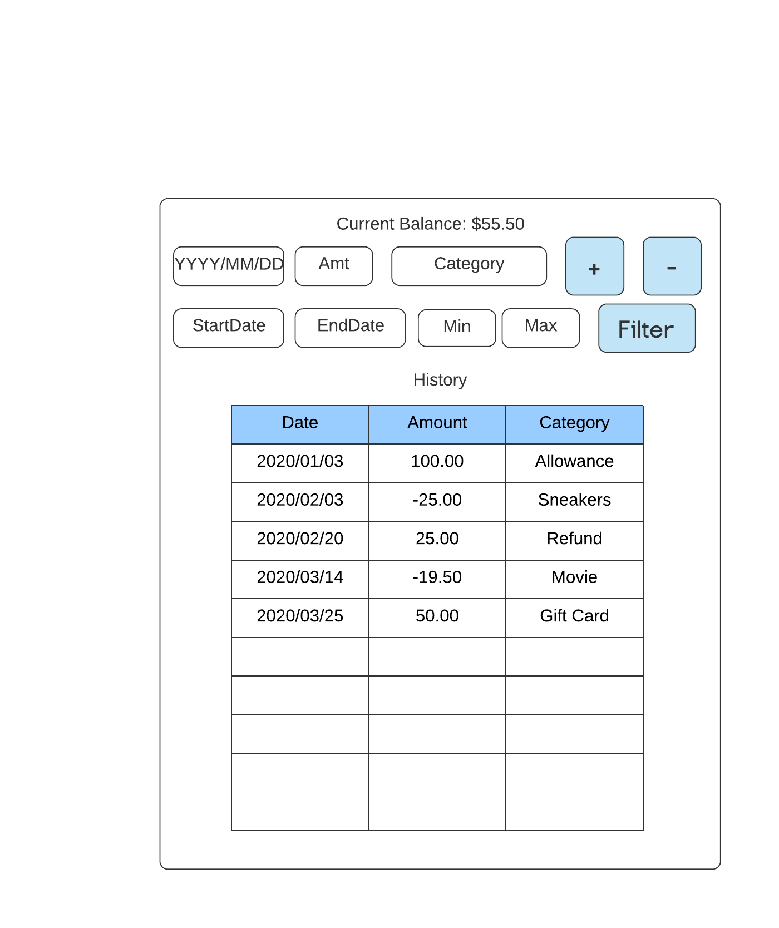As a I user I want to enter in the text boxes (1) the date to filter transactions since 2020/01/01…

(1)

* + 1. 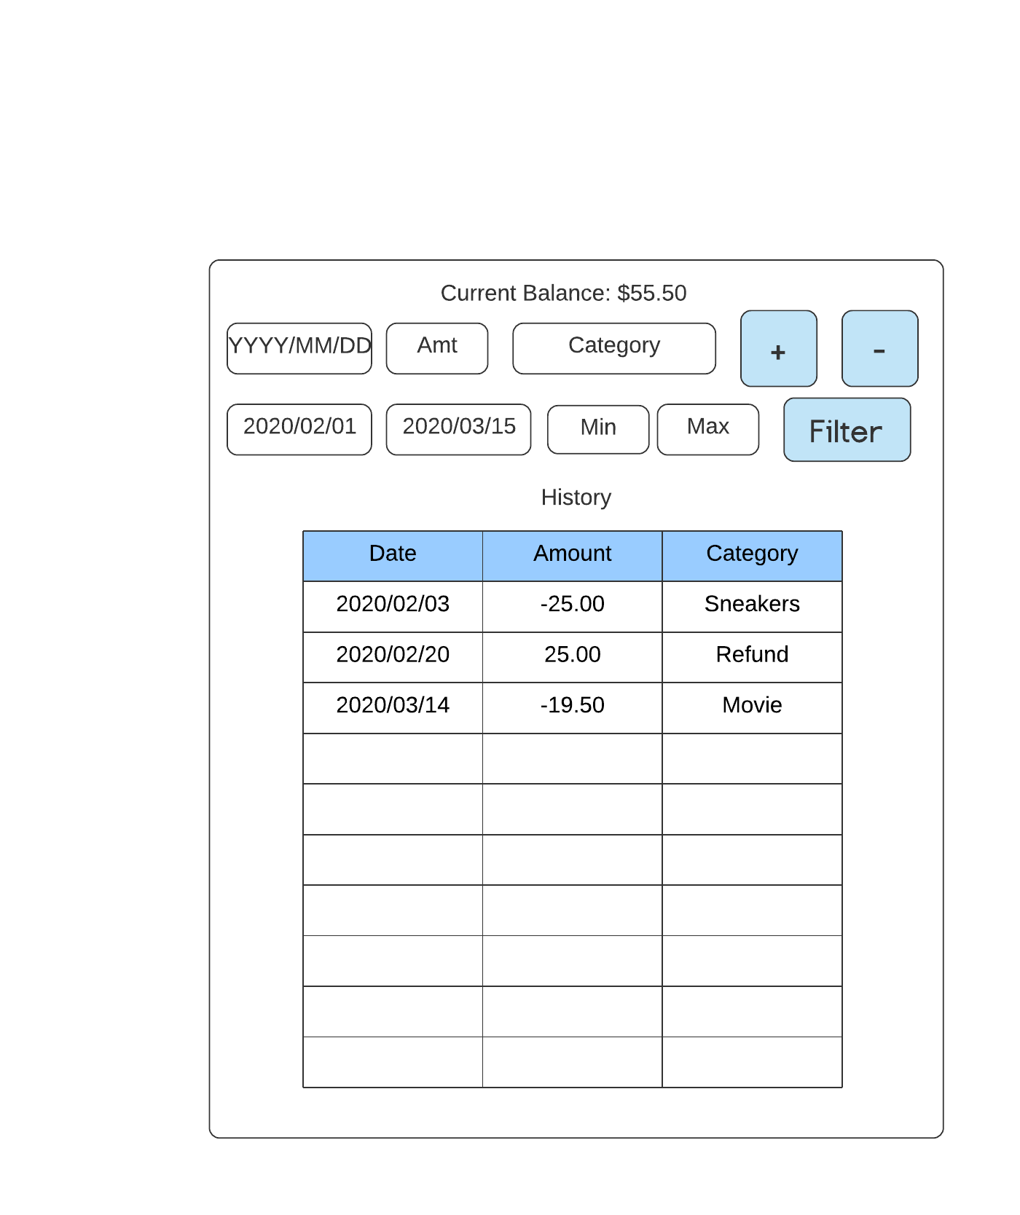I should be able to select a start date (1) and an end date (2) click “Filter” (3), and then the results would be reflected in the Scroll View (3) …

(2)

(3)

(1)

(4)

* + 1. 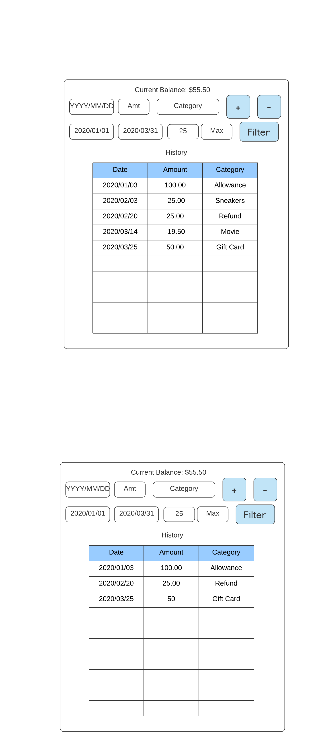As a user I should be able to select a date range and enter a minimum amount to select results greater or equal to that amount…
    2. 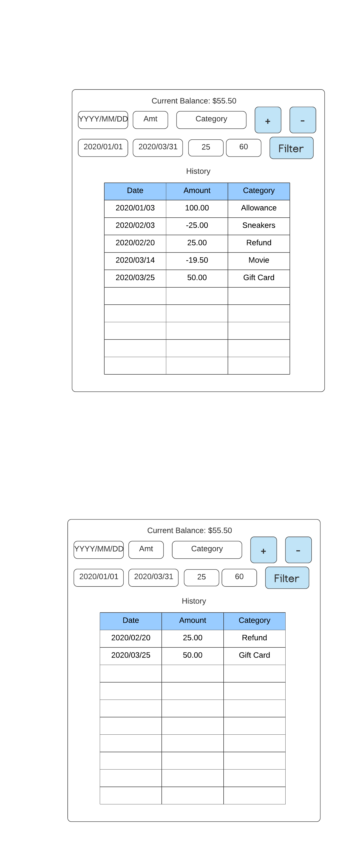As a user I should be able to select a date range and amount range on adding transactions…

* + 1. 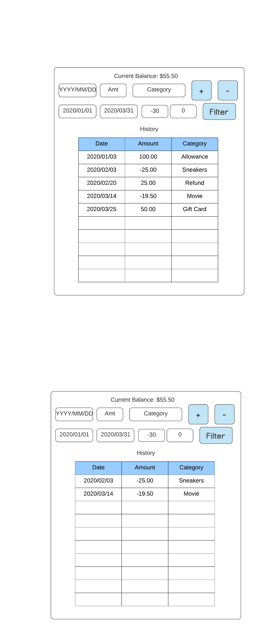As a user I should be able to select a date range and amount range on spending transactions…

